SHRI PANCHAM KHEMRAJ MAHAVIDYALAYA, SAWANTWADI
DEPARTMENT OF COMPUTER SCIENCE
PRACTICAL NO. : 01 | ROLL NO. : | TCS-521
SUBJECT: Computer Network | CLASS : | TYCS
AIM : Using Windows-cmd, execute following networking commands and note the output: ping, traceroute, netstat, arp, ipconfig. | DATE : | 21/06/2025
SOFTWARE USED : Command Prompt. | TEACHER SIGNATURE
Ping
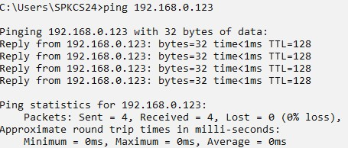
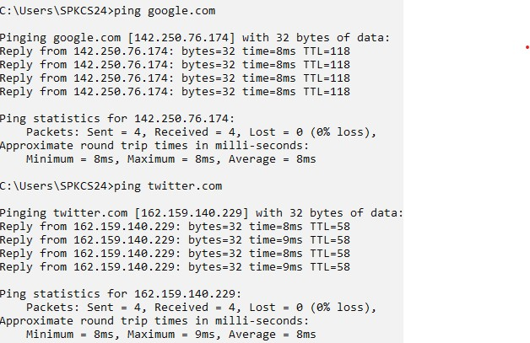

Traceroute
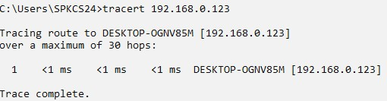

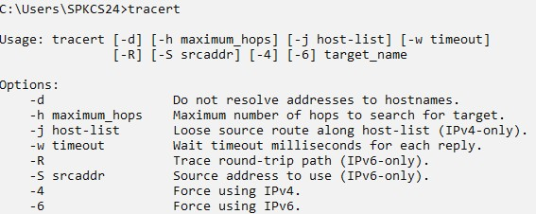

Netstat

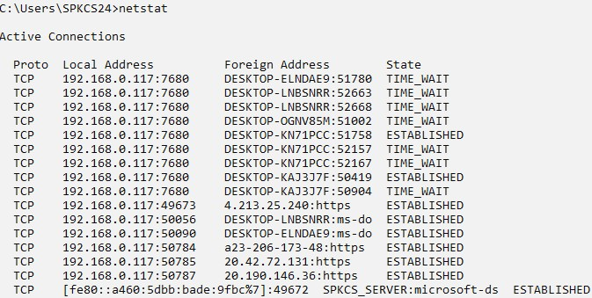
Arp
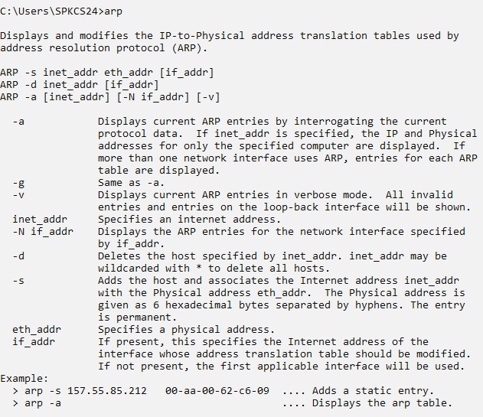

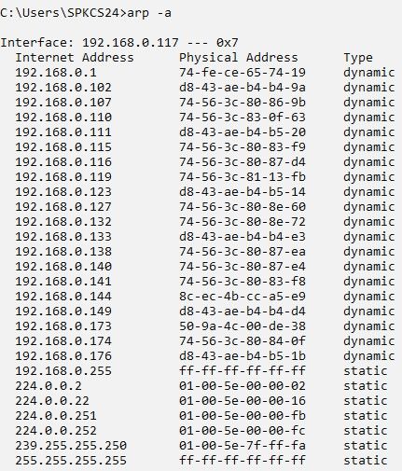

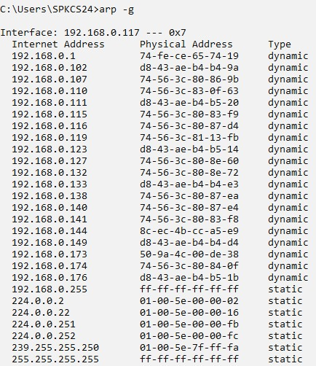

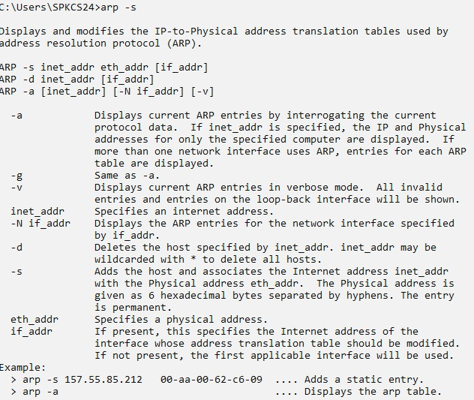

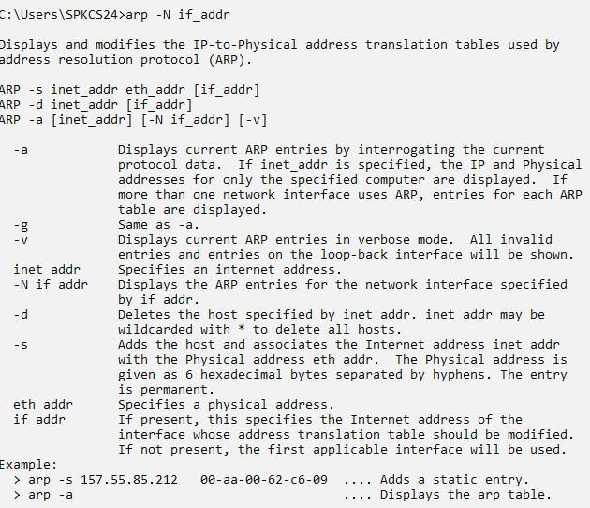

Ipconfig

